What Makes Players Try a Skill Game Machine They Have Never Played Before?
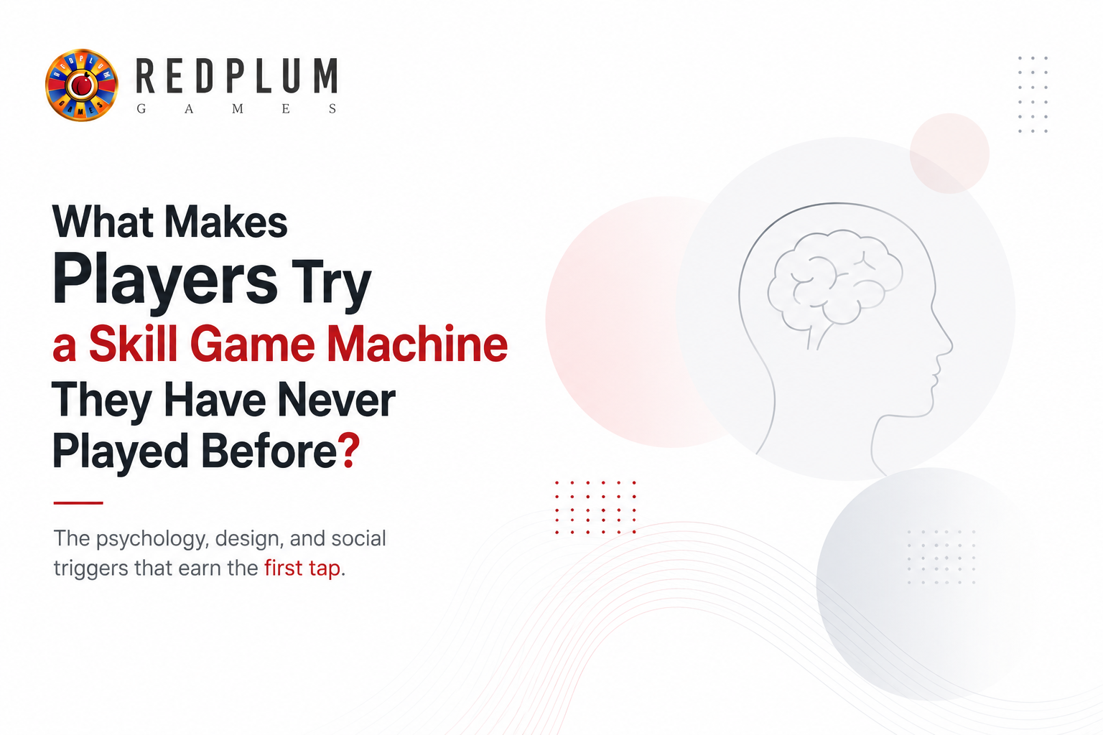
A guy walks past ten machines he already knows and stops at the one he doesn't. He didn't plan to. Something about the screen, the sound, or the crowd around it just pulled him in. That small moment, the second before someone commits a few dollars to a machine they've never touched, is what every operator wants to understand.
Getting a skill game machine first time players haven't tried yet to earn that first tap isn't luck. It's a mix of psychology, design, and a bit of social pressure. Some of it you can plan for. Some of it just happens on the floor, and you learn to spot it after a while.

The Psychology Behind Trying Something New
People don't try new machines because they're bored. They try them because something in the brain rewards the act of exploring. Curiosity isn't just a personality trait, it's chemical, and it shapes buying decisions long before a player reaches for their wallet.

Curiosity Drives First-Time Machine Play
Researchers have linked novelty seeking directly to dopamine activity in the brain. When someone spots an unfamiliar game, the brain treats it as a potential reward, and that alone is enough to pull a player over. According to a 2013 overview of novelty seeking research, the trait involves intense excitement in response to new stimuli, which drives frequent exploratory behavior. That's a fancy way of saying new things that feel good before a single coin drops.
And here's the honest part: this instinct fades with age. A 2023 study found that the decline in curiosity that comes with aging is tied to reduced activity in the brain's dopamine-producing regions. So younger players are naturally more likely to gamble a few bucks on a machine they've never seen before. Older regulars need a bit more convincing, which is exactly why design and placement matter so much for them.
What this means on the floor:
- Players under 30 tend to try a new cabinet within their first two or three visits
- Regulars over 45 often wait until a friend or staff member vouches for it first
- A machine sitting untouched for weeks isn't broken, it just hasn't cleared that trust barrier yet

Novelty Seeking in Arcade Environments
An arcade floor is basically a curiosity lab. Rows of familiar cabinets sit next to something new, and the new one gets the longer stare. This isn't unique to skill games either. It's why grocery stores put new snacks at eye level and why streaming apps keep shuffling their homepage.
The same logic applies to how a floor gets laid out. A cabinet surrounded by five identical machines blends in. The same cabinet next to something visually different, in shape, color, or screen orientation, reads as new even to a returning customer.

Social Proof from Other Players Nearby
People trust a crowd more than they trust a flyer. If three players are huddled around one cabinet laughing or cheering, a fourth person will wander over just to see what's happening. That's social proof doing its job, and it works better than almost any marketing you could put on the machine itself.
A few small things tend to trigger this effect:
- Loud win sounds that carry across the room
- Players standing rather than sitting, since it signals excitement
- A short line or a "wait your turn" moment, which reads as demand

Visual Design That Pulls Players In
Before a player reads a single rule, they've already judged the machine on looks. This happens in under a second, so the visual layer carries more weight than most operators realize.

Bright Themes Like Dragon Vs Tiger Attract Eyes
Bold color contrast and motion catch peripheral vision before anything else does. A title like Dragon Vs Tiger uses sharp reds and golds specifically because they stand out against a wall of quieter cabinets. Bright doesn't mean tacky here, it means visible from across the room.
Color choice does more work than most people expect:
- Red and gold tones signal excitement and high stakes at a glance
- Cool blues and greens work better for calmer, exploration-style themes
- High contrast between background and foreground reads clearly even from twenty feet away

Cabinet Screen Size and Display Quality Matter
A crisp, large screen signals quality before a player reads a single feature. RedPlum Games’ Solaris 43 inch Skill Game Machines are built around this idea, giving new titles a canvas big enough to be noticed from the far end of the floor. Smaller 32 inch or desktop units still work well for tighter spaces, but the visual pull is naturally stronger on the larger screens.
Screen quality affects more than looks too. A washed out or low resolution display makes even a great game feel outdated, and players pick up on that instantly, often without knowing exactly why they walked past it.

Game Themes That Spark Instant Interest
Theme is often the deciding factor before mechanics even come into play. A player doesn't know the paytable yet, but they already know if dinosaurs sound fun.
Theme Style | Example Game | Why It Works
Adventure and exploration | Jurassic | Familiar movie-style excitement
Treasure hunting | Ancient Treasure | Taps into the thrill of discovery
Playful and lighthearted | Piggy Bank Smash | Feels approachable, less intimidating
Western and rugged | Bison Fury | Draws in players who like bold, rustic themes
Fortune and luck | Irish Pot O Gold | Plays on familiar luck symbolism

Adventure Themes Like Jurassic Draw Crowds
Adventure themes borrow from movies and pop culture people already love. A title such as Jurassic doesn't need much explanation because the theme does the talking. Players walk in already knowing what to expect from the world, which lowers the mental effort needed to try it out.

Treasure Hunt Games Like Ancient Treasure Appeal
Everyone likes the idea of finding something valuable. Ancient Treasure leans into that instinct, and it's one reason treasure-themed cabinets tend to pull first-time players faster than plain, generic ones. The visual cues, gold coins, ruins, hidden chambers, all reinforce the same promise before a single spin happens.

Playful Themes Like Piggy Bank Smash Stand Out
Not every new player wants intensity. Some want something light and fun to start with. A game named Piggy Bank Smash feels low pressure, which makes it a smart entry point for someone who has never played a skill game machine before.

Wild West Themes Like Bison Fury Feel Familiar
Familiarity within a new package is powerful. Bison Fury uses a Western theme most players already recognize from movies and shows, so the unfamiliar mechanics feel a little less risky to try. New rules feel safer when the setting isn't also new.

Machine Features That Build Confidence to Play
Once a theme catches attention, the machine still has to earn trust. Confusing controls kill first-time interest fast, no matter how good the graphics look.

Clear Instructions Reduce First-Time Hesitation
If a player has to ask a staff member how to play, some will just walk away instead. On-screen tutorials and simple button layouts remove that friction almost entirely. A quick "how to play" screen at the start does more for conversion than most operators give it credit for.
Features that tend to reduce hesitation:
- A short animated tutorial that runs automatically on idle screens
- Large, clearly labeled buttons instead of unlabeled icons
- Visible point or dollar value so players know exactly what they're spending
- A demo mode that lets players watch a round before committing money

Recall Rewards Makes Return Visits Easy
RedPlum's proprietary Recall Rewards feature is built to reward loyalty after that first play, encouraging a nervous first-timer to become a repeat player. Once someone has a good first session, a small reward for coming back removes a lot of the hesitation around trying the machine again. The goal isn't to win them over in one sitting, it's to make the second visit feel worth it too.

The Role of Jackpots and Bonus Rounds
Jackpots aren't just a payout structure. They're a marketing tool that operates in plain sight, all day, without a single ad.

Progressive Jackpots Create Instant Excitement
A visible jackpot number climbing higher every hour is one of the strongest pulls on an arcade floor. It doesn't need explanation. Bigger number, bigger interest, simple as that. Players glance at it, do quick mental math on the risk, and decide in seconds whether it's worth a shot.
What makes a progressive number effective:
- A large, easy to read display separate from the main game screen
- Visible growth over time, even by small amounts, since static numbers stop drawing eyes
- A reset or celebration moment when it hits, which resets curiosity across the whole floor

Cabinet Placement and Floor Visibility
Even the best game in the world underperforms in a bad spot. Where a machine sits on the floor can matter as much as what's on the screen.

Solaris 43 Inch Cabinets Command Attention
Larger cabinets like the Solaris series work best near entrances or main walkways where foot traffic is heaviest. Size alone earns a second look, and a second look is often all it takes.
Placement choices that tend to work well:
- Entrance-facing rows, since new visitors haven't formed habits yet
- Near redemption kiosks, where players are already thinking about prizes
- End caps of aisles instead of the middle, where sightlines are wider
- Away from noisy machines that compete for the same attention

High Traffic Placement Increases First Tries
Machines tucked into back corners rarely get discovered, no matter how good the game is. Operators who track play data usually notice that identical cabinets perform very differently depending on placement alone, sometimes by a wide margin. Moving a slow performer just fifteen feet closer to the entrance can change its numbers within a week.

How Operators Can Encourage New Player Trials
Design and placement only get you halfway there. What operators do day to day still shapes whether new games get tried at all.
- Rotate new titles onto the floor every few months to keep things fresh
- Train staff to point curious players toward newer cabinets instead of just the familiar ones
- Offer flexible point or dollar play so trying something new feels low risk
- Watch play data closely and move underperforming cabinets to better spots
- Pair new titles with a small first-play incentive during launch week
- Keep a mix of intense and lighthearted themes so every visitor finds an easy entry point

Rotating New Titles Keeps the Floor Fresh
A floor that never changes starts to feel invisible to regulars. Swapping in new titles a few times a year, even just reshuffling familiar ones into new spots, resets that curiosity effect discussed earlier.

Staff Recommendations Build Player Trust
A short word from staff carries more weight than any sign on the cabinet. "That one's new, people are liking it" is often all it takes to get someone to try their first spin. Staff who know the machines well, and can answer a quick question without hesitating, remove the last bit of friction standing between a curious glance and an actual play.

Simple Point or Dollar Play Options Help
Games that let players choose between points or dollar play, a standard feature across RedPlum's full game library of Skill Games, lower the barrier for someone deciding whether the risk feels worth it. Letting a player start small on a machine they've never touched matters more than any feature on the screen.
The amusement machine industry isn't slowing down either. The global market is projected to grow from roughly $15.72 billion in 2024 to $17.54 billion in 2025, and more venues means more competition for that first glance a player gives a new cabinet. Standing out matters more now than it did five years ago.

Final Thoughts on Winning Over First-Time Players
None of this works in isolation. A bold theme without a visible jackpot falls flat. A great placement without clear instructions still loses nervous players at the controls. The machines that consistently earn a first try combine all of it: something for the eye, something for the brain's reward system, and something that makes the whole thing feel easy to walk away from without regret if it doesn't work out.
Get that combination right, and a first-time player doesn't just try the machine once. They come back looking for it by name.
Looking to add machines built around this exact kind of pull?Visit RedPlum Games to see the full cabinet lineup and talk to the team about what fits your floor. RedPlum also offers skill games machines in Texas and skill games in Texas for operators ready to bring this same pull to their location.

